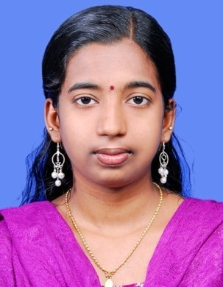

RESHMA KONUR

(Thippilikat house 39/1933,Govindapuram (P.O),calicut-16, Kerala state, India)
E-Mail: konurreshma@yahoo.com, Phone: 9656264893

Career Objective

Intend to build a career with leading corporate of hi-tech environment with committed and dedicated people, which will help me to explore myself fully and realize my potential. Willing to work as a key player in challenging and creative environment.
Professional Experiences

Worked as a Sales Development Manager in “HDFC LIFE” at Calicut, From June 2010 to December 2010

Company :HDFC life, Calicut.
Designation : Sales development manager.
Job Profile : create sales pitches to my team members, recruiting financial consultants, Organise and direct a team, customer service.
Job Responsibilities:
- To demonstrate how the products and services operate team, as well as potential clients.
- Informing team members what needs to be accomplished and how to go about it.
- Plan the execution of marketing directions and strategies meant to help the sales force attain the required sales target.
- Coordinate with HR to ensure the sales floor maintains the budgeted number and compensation package for its sales force.
- Involve customers in feedbacks and survey questionnaire to gauge success of promotions and product selling strategies.
- Interact with the customers and solve their insurance related problems.
- Invite customers for feedback focus group discussion with marketing executives and assist market research staff in elicit response to questionnaires and survey forms.

Academic Educational Profile

- M.b.a. in [HR] from September 2010 to January 2013 [Sikkim Manipal University].
- Degree in [History] from August 2007 to March 2010 [Calicut University].

Extra Curricular Activities

- Visited KITEX limited at Kochi, Kerala. Had a detailed introduction about the production.

Academic Project

In MBA: Job satisfaction of employees.
Software Exposure

- Diploma in Indian and Foreign Accounting, Windows XP, MS-Office.

Achievements

- Participated in many college symposiums and various cultural events.
- Participated in R&D Presentation.
- Chairperson in school level.

Personal Skills

- Comprehensive problem solving abilities, verbal and written communication skills
- Proficient in working on quadrant and so time management skill.
- Ability to deal with people diplomatically,
- Independent problem solving, self direction & able to follow instructions well.

Area of Interest

- Management.

Personal Information

Name : ReshmaKonur.R
Date of Birth : 03-07-1987
Marital Status : Married.
Husband’s name : AnbuSelvan.R
Sex : Female.
Languages Known : English,Hindi,Malayam,Tamil.
Nationality : Indian
Passport number : K5218325
Pan card number : AVRPR7258M
Permanent Address : 39/1933, Thippilikat house, Govindapuram Post,
Calicut – 673016, Kerala, India.

Declaration

I hereby declare that the information furnished above is true to the best of my knowledge.

Date:
Place: Calicut (RESHMA KONUR)

